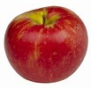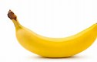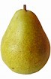

Fruit
How many apples? ______
How many pears? _______
How many bananas? ______
How many apples and bananas? _______
How many apples and pears? _______
How many pears and bananas? ________

