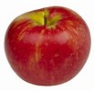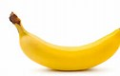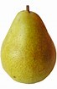

Fruit

How many apples? ______

How many pears? _______

How many bananas? ______

How much fruit? _______

