Fiore’s Fabulous Fruitcake name _____________________________

Makes: 2 medium loaves or 3 mini loaves (24 slices total)
1 1/2 cups fresh orange juice
- 1 1/2 cups chopped candied orange peel, (about 8 ounces)
- 1 cup chopped dried cherries, (about 6 ounces)
- 1 cup chopped dried apricots, (about 6 ounces)
- 1 cup chopped dried pineapple, (about 6 ounces)
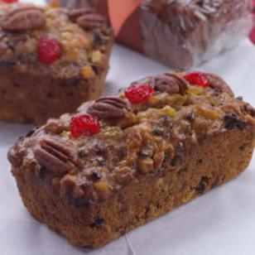
- 3/4 cup currants, (about 4 ounces)
- 1 cup all-purpose flour, divided
- 3/4 cup whole-wheat pastry flour
- 1 teaspoon ground cinnamon
- 1/2 teaspoon ground allspice
- 1/2 teaspoon baking powder
- 1/2 teaspoon salt
- 1/2 cup sugar
- 1/4 cup mild extra-virgin olive oil, or walnut oil
- 2 tablespoons unsalted butter, at room temperature
- 3 tablespoons molasses
- 1 teaspoon vanilla extract
- 2 large egg whites, divided
- 3 glacéed red cherries, cut in half, for garnish
8 pecan halves, for garnish

Well you can see that it takes Fiore about a week to make this fruitcake!
Finding all this stuff isn’t easy!

How many cups of dried fruit including currants? ________________
How many cups of fruit including candied orange peel? _____________
How teaspoons of spices? ____________
How many cups of flour? ___________
A cup has 16 tablespoons in it.
What fraction of a cup of butter?_______
What fraction of a cup of molasses? _______

Per slice: 202 calories; 4 g fat (1 g sat, 2 g mono); 3 mg cholesterol; 42 g carbohydrates; 2 g protein; 3 g fiber; 78 mg sodium; 269 mg potassium.

How many calories in all the fruitcake? _____________
How many calories per mini-loaf? ___________
How many slices per mini-loaf?_________

http://www.eatingwell.com/category/health_diet_considerations/low_calorie

